Experiment No. 2

Given a relation Emp in the following figure

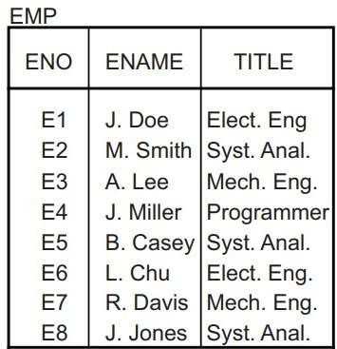

Let p1: TITLE< “Programmer” and p2: Title> “Programmer” be two simple predicates, Assume that character strings have an order among them, based on the alphabetical order.

a) Perform a horizontal fragmentation of relation EMP with respect to {p1, p2}.

b) Explain why the resulting fragmentation (EMP1, EMP2) does not fulfill the correctness rules of fragmentation.

c) Modify the predicates p1 and p2 so that they partition EMP obeying the correctness rules of fragmentaion. To do this, modify the predicates, compose all minterm predicates and deduce the corresponding implications, and then perform a horizontal fragmentation of EMP based on these minterm predicates. Finally, show that the result has completeness, reconstruction and disjointness properties.

**Objective:** Apply horizontal fragmentation on distributed databases.

**Solution: a)** Given two simple predicates p1: TITLE<“Programmer” and p2: TITLE>“Program-

mer”.

If we assume that the character strings have an order among the relation EMP, based on the alphabetical order. Then the “TITLE” will be of the following order:

Elect Eng.

Mech Eng

Programmer

Syst Anal

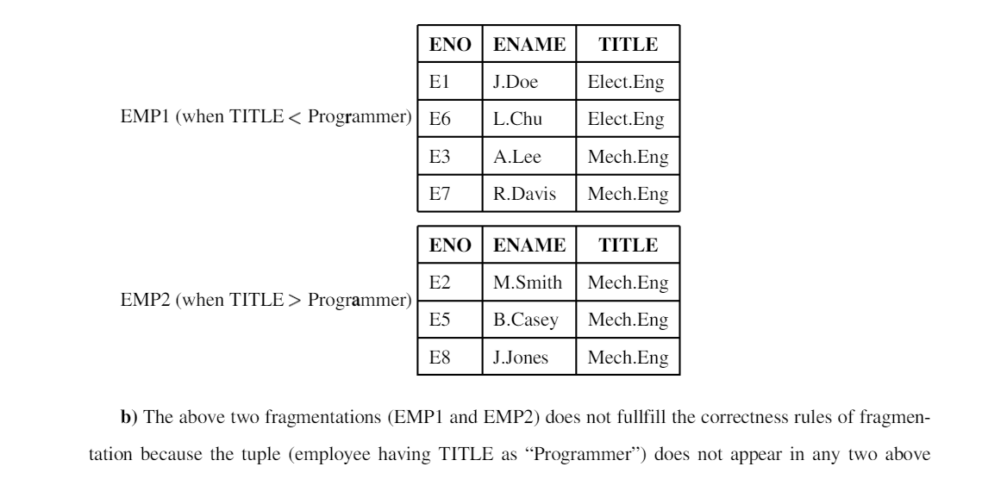

**b)** The above two fragmentations (EMP1 and EMP2) does not fullfill the correctness rules of fragmentation because the tuple (employee having TITLE as “Programmer”) does not appear in any two above a completeness in the horizontal fragmentation.

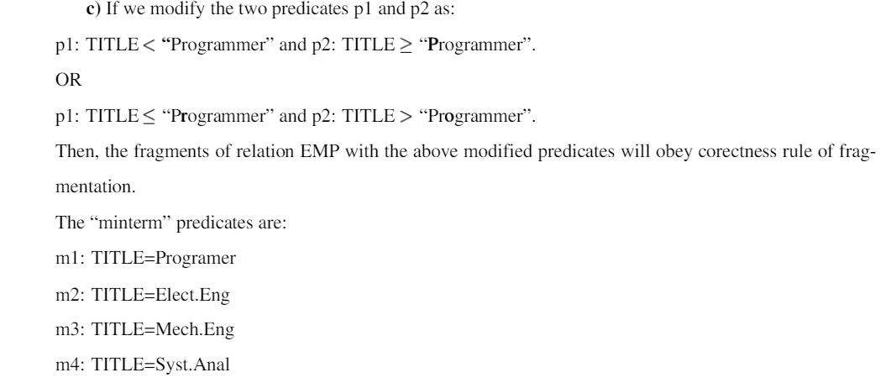

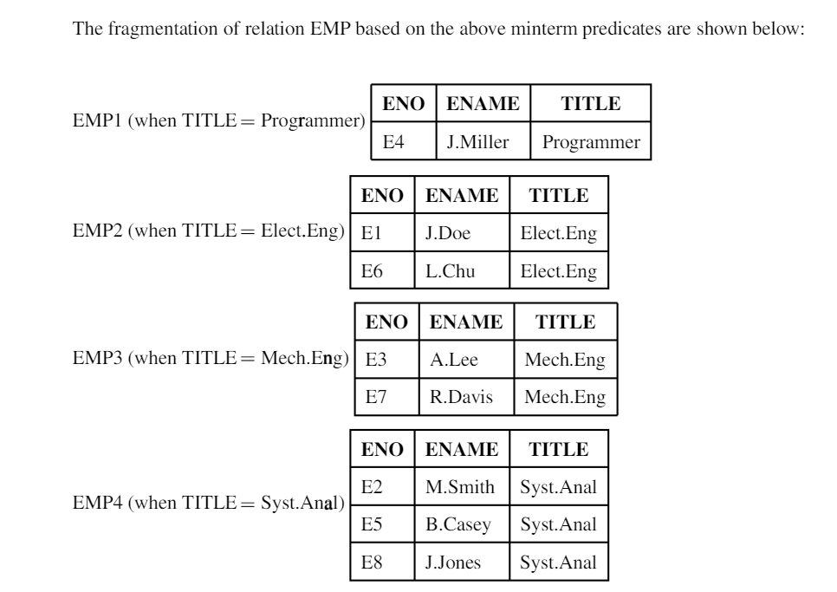

Completeness: The above four fragments have all data items which are in EMP relation. Thus, there is

Completeness: The above four fragments have all data items which are in EMP relation. Thus, there is

Completeness: The above four fragments have all data items which are in EMP relation. Thus, there is

**Completeness:** The above four fragments have all data items which are in EMP relation. Thus, there is a completeness in the horizontal fragmentation.

**Reconstruction:** The above fragments can be reconstructed by using the relational algebra as:

The above fragments can be reconstructed by using the relational calculus as:(select ENO,ENAME,TITLE from EMP1) union (select ENO,ENAME,TITLE from EMP2) union (selectENO,ENAME,TITLE from EMP3) union (select ENO,ENAME,TITLE from EMP4);

**Disjointness:** In the above four fragments, tuples does not have the same values in different fragments. Thus there is a disjointness in the horizontal fragmentation.